Measuring Environmental Impact

Carbon Footprinting
Though we have an estimate of the NHS’s carbon footprint overall, the carbon impact of quality improvement projects is not routinely measured. In order for the NHS to reduce its greenhouse gas emissions to net zero by 2040, carbon needs to become an additional currency alongside money, understood by all working in the health system.

For more in depth carbon footprinting beyond this summary guide, CSH offer a carbon footprinting for healthcare online course. More info here: Carbon Footprinting for Healthcare | Centre for Sustainable Healthcare

Contents:
- What is a carbon footprint?
- Planning your carbon footprinting study
- Case study example – carbon calculations
- Templates
  - Resource use table
  - Calculating change in carbon footprint table
- Non carbon impacts
- Appendix: Useful greenhouse gas (GHG) emissions factors

What is a carbon footprint?
A carbon footprint is the sum of greenhouse gas (GHG) emissions attributable to a given process. Six different types of gases are commonly included; as each has a different global warming potential, the quantities are expressed in “carbon dioxide equivalents” (CO₂e). This is shown in Table 1 below.
The impact of a QI project on the NHS carbon footprint can be estimated by converting data for example on services, consultations, hospital admissions, travel and other activities into kilograms of CO₂e.

Carbon footprint (kg CO₂e) = activity or resource use x GHG emissions factors

A GHG emissions factor is the average emission rate of a given resource. Emissions factors can be found in databases, some of which are publicly accessible (e.g. those published by the UK Government Department of Business, Energy & Industrial Strategy, BEIS).

Table 1: Global warming potential of some GHGs used in healthcare:
Source: Intergovernmental Panel on Climate Change Sixth Assessment Report (AR6)

Greenhouse gas (GHG) | Healthcare use | 100-year global warming potential
CO₂e | Embedded carbon from energy use in buildings, travel and supply chain | 1
Hydrofluorocarbons (HFCs) | Anaesthetic vapours, inhaler propellants e.g. MDI’s  (also refrigerants) | 195 (sevoflurane)  539 (isoflurane)  2590 (desflurane)
Nitrous oxide (N₂O) | Anaesthetic agent | 273

Planning your carbon footprint study
Step 1. Define the goal and scope of your study

Do you want to understand the make-up of the carbon footprint of the entire service or just to quantify the impact of your specific QI project? Will you want to be able to compare with other projects or services? Think about how you will use the study results as this will affect the data you choose to collect.

Step 2. Identify the resource that you will measure (set boundaries, create inventory)

This will be based on: which resources you expect to change as a result of your project, the practicalities of data collection, and the available emissions factors for conversion into CO₂e.

First consider the resources/activities required to deliver the service before and after your change. These may include, patient and staff travel, energy, medications, medical equipment/supplies, non-medical equipment/supplies. Tables to do this can be found in the Studying the System Section. You can use this table to review the potential impact of your change on different categories of resource use – and to consider how it could be measured. Include any resources needed to introduce the change – e.g. new equipment.

It is also important at this stage to consider what emissions factors you will apply in Step 4, in order to convert your data into CO₂e (see sample emissions factors at end of the document). You are unlikely to have emissions factors available for individual medications or items of medical equipment and may therefore need to track changes in financial spend for these categories. Depending on your QI project, it might be easiest to estimate the carbon impact from changes in units of healthcare activity, such as outpatient appointments, A&E attendances, inpatient bed-days.

Finally, write down what you are including in your carbon footprint study and what you are not. Without this, it is not possible for others to interpret your results or make comparisons.

Step 3. Measure the resource utilisation (collect data)

Gather the data for each resource category that you have identified and calculate the change in utilisation as result of your QI project.

Step 4. Attribute a carbon cost or footprint to the resources used (apply emissions factors)

Using Table 2 ‘Calculating change in carbon footprint’ in the Measuring environmental impacts form, enter the data you collected in Step 2 on activity/resource and the emissions factor you have selected – now multiply these together and add up the results!

Case study example – carbon calculations
At an NHS trust in England, cannulae were inserted routinely in patients attending A&E. All cannulae were fitted with a bionector for infection control purposes. However, an audit found that many cannulae were not used or used inappropriately. After deciding to reduce cannulation, the hospital reduced the number of cannulae use by 105 and the number of bionector use by 98 in one week. How much carbon emissions did the hospital save?
105 fewer cannulae were used (Cost: £1.80, weight: 0.061kg)
98 fewer bionectors were used (Cost: £3.51, weight: 0.01kg)
Carbon emission factors
*Please note that the below example is based on the most up to date emission factors so savings might not match the original case study. See Appendix 1 for source of emission factors.
Non-electrical medical consumables: 0.672 kgCO₂e/£
Clinical/sharps waste incineration: 1074 kgCO₂e/tonne
Calculation: Carbon emissions saved
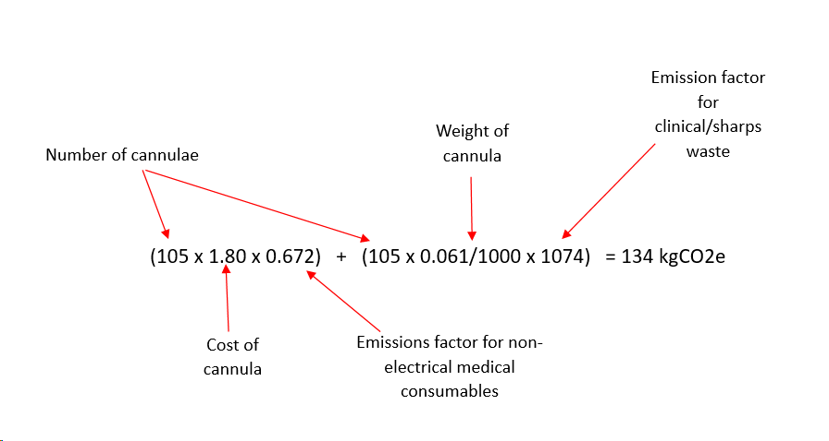
Cannula:

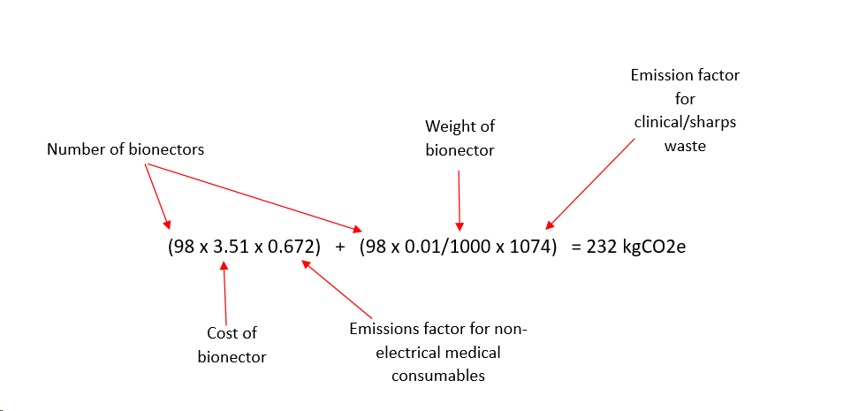
Bionector:

In total the A&E department saved 366 kgCO₂e in one week by reducing cannulation. Over a year the GHG emissions savings would amount to 19,032 kgCO₂e.

Table 1. Resource use
You can use this table to review the potential impact of your change on different categories of resource use – and to consider how this could be measured. You may be approaching this looking at individual items or at a larger scale such as units of healthcare. Both are included in this table.
Resource |  | Potential impact of your service change (positive or negative) | What data is available/ could be collected?
1. Medical  Supplies | Medications
 | Anaesthetic gases / nitrous oxide
 | Propellant (MDI) inhalers
 | Medical & surgical equipment
 | Dressings
 | Other, specify…
2. Non-Medical  Supplies | Office equipment, telecomms, computers & stationery
 | Furniture fittings
 | Provisions
 | Other, specify …
3. Travel | Staff travel
 | Patient and carer travel
4. Other Resources | Energy use
 | Water use
 | Waste disposal
5. Units of healthcare activity | Inpatient bed-day
 | Outpatient appointment
 | GP appointment
 | Surgical or other procedure

Table 2. Calculating change in carbon footprint
Activity/resource | Activity change: change in each activity/ resource over defined period | Emissions factor (kgCO₂e per [unit should match units for activity/resource]) | Carbon impact: activity change x emissions factor (kgCO₂e)
1.
2.
3.
4.
5.
 |  | Total change in carbon footprint (kgCO₂e):

Non-carbon impacts
Carbon footprint is an important measure of environmental impact, but it is not the only one. Consider whether any of the following environmental impact categories apply to your project, too:
- Air pollution from burning fossil fuels during transport or power generation, or from waste incineration
- Deforestation, landscape degradation, loss of biodiversity – from building and management of healthcare facilities, as well as building, mining and cultivation in the supply chain (including rubber plantations for glove manufacture)
- Depletion of scarce natural resources, including fresh water
- Bio-accumulation and toxicity of chemicals entering the environment, often through water pollution (antibiotics, antidepressants, contraceptives, propofol)
- Plastic pollution from inadequate waste disposal systems / littering

Appendix: Useful GHG emissions factors

- Medical Supplies
Table 1 provides a summary of emission factors for NHS financial spend on various medical supplies. The emission factor for each item category has been taken from the UK Government 2021 dataset including conversion factors by SIC code and broken down further into eClass description by Greener NHS.
You can view the full UK Government dataset here: UK and England's carbon footprint to 2021 - GOV.UK (www.gov.uk) or see the full breakdown of eclass mapping on the GNHS Knowledge Hub here: eClass to SIC mapping - Greener NHS Knowledge Hub - FutureNHS Collaboration Platform (NHS log in required to access FutureNHS).

Table 1: Medical supplies GHG emission factors taken from Greener NHS Knowledge Hub.
Medical item category | UK SIC code description | DEFRA SIC 2021 GHG emission factor (kgCO2e/£)
Staff clothing (e.g. uniform) | Wearing apparel | 0.738
Theatre wear (e.g. caps, clothing, gowns, socks) | Other manufactured goods | 0.617
Continence products, sanitary pants & pads | Paper and paper products | 0.756
Pharmaceuticals and blood products | Basic pharmaceutical products and pharmaceutical preparations | 0.581
Unmedicated bandages and dressings (e.g. compression bandages, tubular bandages, absorbent dressings, surgical tape, silicone gel dressings) | Other manufactured goods | 0.617
Medicated bandages and dressings (e.g. charcoal dressing, hydrogel dressing, hydrocolloid dressings) | Basic pharmaceutical products and pharmaceutical preparations | 0.581
Gauze (e.g. cotton balls, swabs gauze, cotton gauze) | Textiles | 0.805
Nonelectrical medical consumables/equipment (e.g. procedure packs, nasogastric tubes, disposable surgical instruments, syringes, needles, cannulas, catheters) | Other manufactured goods | 0.617
Electrical medical consumables/equipment (e.g. enteral feeding pumps, pulse oximeter, syringe drivers, x-ray and CT equipment) | Computer, electronic and optical products | 0.404
Chemicals and reagents (e.g. pathology analysers, radioactive indicators, X-ray imaging film) | Other chemical products | 1.338
Bed linen (disposable bed linen, reusable bed linen, sheets, blankets, pillow slips) | Textiles | 0.805
Dietetic food | Other food products | 0.725
Medical furniture (e.g. benches, chairs, couches, drug cabinets) | Other manufactured goods | 0.617

Anaesthetic gases
GHG emissions factors per litre of:
- Desflurane: 3,721.1 kgCO₂e / litre
- Isoflurane: 762.96 kgCO₂e / litre
- Sevoflurane: 197.86 kgCO₂e / litre
- Nitrous oxide: 0.559 kgCO₂e / litre
- Nitrous oxide with oxygen 50/50 split: 0.278 kgCO₂e / litre

Source: Greener NHS 20/21 database

Metered dose inhalers
GHG emissions factors per inhaler:
- Large volume inhaler (MDI), e.g. Ventolin: 24 kgCO₂e / inhaler
- Small volume inhaler (MDI), e.g. Salamol: 10 kgCO₂e / inhaler
- Dry Powder inhaler: < 1 kgCO₂e / inhaler

Source: Wilkinson AJK et al. Costs of switching to low global warming potential inhalers. An economic and carbon footprint analysis of NHS prescription data in England. BMJ Open Access. Sep 2019. https://bmjopen.bmj.com/content/bmjopen/9/10/e028763.full.pdf
If you’re looking for a specific inhaler carbon emission factor please use the PrescQIPP database: Bulletin 295: Inhaler carbon footprint | PrescQIPP C.I.C

PPE
- Single glove: 0.026 kgCO2e / item
- Cup fit FFP respirator: 0.125 kgCO2e/item; duckbill FFP respirator 0.076 kgCO2e / item
- Type IIR surgical mask: 0.02 kgCO2e, type II surgical mask: 0.013 kgCO2e / item
- Face shield: 0.231 kgCO2e / item
- Apron: 0.065 kgCO2e / item
- Single-use gown: 0.905 kgCO2e / item

Source: Rizan C, Reed M, Bhutta M. Environmental impact of Personal Protective Equipment supplied to health and social care services in England in the first six months of the COVID-19 pandemic. Journal of the Royal Society of Medicine; 0(0) 1–14, DOI: 10.1177/01410768211001583, https://journals.sagepub.com/doi/full/10.1177/01410768211001583
- Reusable surgical gown: 0.557 kgCO2e* / use
*To note: data taken from an American study, therefore carbon intensity of electricity grid is likely to be higher than in the UK re. sterilisation.
Source: Vozzola E, Overcash M, Griffing E. An Environmental Analysis of Reusable and Disposable Surgical Gowns. AORN J. An Environmental Analysis of Reusable and Disposable Surgical Gowns - PubMed (nih.gov)

- Non-medical supplies
Table 2 provides a summary of emission factors for NHS financial spend on various non- medical supplies. The emission factor for each item category has been taken from the UK Government 2021 dataset including conversion factors by SIC code and broken down further into eClass description by Greener NHS.
You can view the full UK Government dataset here: UK and England's carbon footprint to 2021 - GOV.UK (www.gov.uk) or see the full breakdown of eclass mapping on the GNHS Knowledge Hub here: eClass to SIC mapping - Greener NHS Knowledge Hub - FutureNHS Collaboration Platform (NHS log in required to access FutureNHS).

Table 2: Non-medical supplies GHG emission factors taken from Greener NHS Knowledge Hub.
Non-medical item category | UK SIC code description | DEFRA SIC 2021 GHG emission factor (kgCO2e/£)
Catering equipment (e.g. ovens, hobs, fridges) | Machinery and equipment | 0.445
Cleaning materials & products (e.g. disinfectant, bleach, cleaning consumables) | Soap and detergents, cleaning and polishing preparations, perfumes and toilet preparations | 0.837
Non-medical furniture (e.g. office chairs, tables, desks) | Furniture | 0.457
Computer hardware and software (e.g. computer, printers, laptops) | Computer, electronic and optical products | 0.404
General stationary (e.g. desktop accessories, binders, notepads, envelopes, labels) | Paper and paper products | 0.756

- Travel
Travel – average emissions by mode of transport:
- Bus (local, not London): 0.16173 kgCO₂e / passenger.km
- Bus (local, London): 0.09268 kgCO₂e / passenger.km
- Car (unknown fuel): 0.33939 kgCO₂e / mile
- Train (national rail): 0.04443 kgCO₂e / passenger.km
- Train (light rail): 0.03609 kgCO₂e / passenger.km
- Regular taxi: 0.18558 kgCO₂e / passenger.km
- Black cab: 0.25492 kgCO₂e / passenger.km

Emission factors include well-to-tank emissions (WTT). Source: Government emission conversion factors for greenhouse gas company reporting 2024 Greenhouse gas reporting: conversion factors 2024 - GOV.UK (www.gov.uk)

- Other Resources
Energy
- Electricity use (UK): 0.27522 kgCO₂e / kWh
- Natural gas: 0.21311 kgCO₂e / kWh

Emission factors include well-to-tank emissions (WTT). Source: Government emission conversion factors for greenhouse gas company reporting 2024 Greenhouse gas reporting: conversion factors 2024 - GOV.UK (www.gov.uk)

Water use
Water use: 301.7 kgCO₂e / million litres: 0.3017 kgCO₂e / m3

Source: Government emission conversion factors for greenhouse gas company reporting 2024 Greenhouse gas reporting: conversion factors 2024 - GOV.UK (www.gov.uk)

Waste disposal:
- Recycling: 21 kgCO₂e / tonnes
- Recycling reusable instruments: 21 kgCO₂e / tonne
- Recycling reusable surgical linens: 21 kgCO₂e / tonne
- Recycling batteries: 65 kgCO₂e / tonne
- Low temperature incineration with energy for waste - dry mixed recycling, domestic waste : 172 kgCO₂e / tonne
- Low temperature incineration with energy for waste – non-infectious offensive waste: 249 kgCO₂e
- Autoclave decontamination plus Low temperature incineration with energy for waste – infectious waste: 569 kgCO₂e / tonne
- High temperature incineration – clinical waste, medicinal contaminated sharps, anatomical waste, medicinal waste 1074 kgCO₂e /tonne

Source: Rizan C, Bhutta M, Reed M, Lillywhite R. The carbon footprint of waste streams in a UK hospital. Journal of Cleaner Production 286 (2021) 125446. https://www.sciencedirect.com/science/article/abs/pii/S0959652620354925

- Units of healthcare activity
Outpatient appointments in GP and acute sectors (includes travel):
- GP appointment: 9.9 kgCO₂e
- GP home visit (staff): 9 kgCO₂e
- GP telephone consultation: 0.05 kgCO₂e
- GP video consultation: 0.03 kgCO2e
- Acute outpatient appointment (face to face): 22 kgCO₂e
- Acute outpatient telephone appointment: 0.1 kgCO₂e
- Acute outpatient video consultation: 0.06 kgCO2e
- Acute day case: 124 kgCO₂e
- Elective inpatient stays: 618 kgCO₂e
*use this factor when the number of bed days is unknown.
- Non-elective inpatient stays (long stays): 503 kgCO₂e
*use this factor when the number of bed days is unknown.
- Non-elective inpatient stays (short stays): 126 kgCO₂e
*use this factor when the number of bed days is unknown.

Source: GP appointment, GP home visit, GP and outpatient telephone consultation taken from Greener NHS business case carbon impact tool v3. All other emission factors taken from PSSRU(2019).
Available from:
https://www.pssru.ac.uk/project-pages/unit-costs/unit-costs-2019/

- Inpatient bed day – low-intensity ward – 37.9 kgCO₂e/ bed day
- Inpatient bed day – high-intensity ward – 89.5 kgCO₂e/ bed day
- A&E (emergency department) visit: 13.8 kgCO₂e
- Surgical procedure (66 minutes): 35.1 kgCO₂e
- Community visit: 23 kgCO₂e

Source: Care pathways guidance on appraising sustainability (Sustainable Development Unit, 2015) Available from: Sustainable Development Unit (SDU) carbon footprints of various units of healthcare activity | CSH Networks (sustainablehealthcare.org.uk)

