Value Process Mapping

# Introduction

Process mapping is used to develop a 'map' of a process within a system; it maps how a process operates in reality rather than how it might ideally work. Process mapping can be used to help a team understand where the problems are and identify areas for improvement.

The scope will vary; you could map the whole patient journey or a specific diagnostic pathway. Those involved in carrying out different roles within the pathway will need to be involved in making the map to ensure that the process map accurately reflects what is happening in practice.

# Step 1: create your map

Start with a high-level process map of say 5 to 10 steps which you set a time limit to achieve e.g. 20 minutes. This helps to establish the scope of the process and identify significant issues. Here is a simple example of a process map.

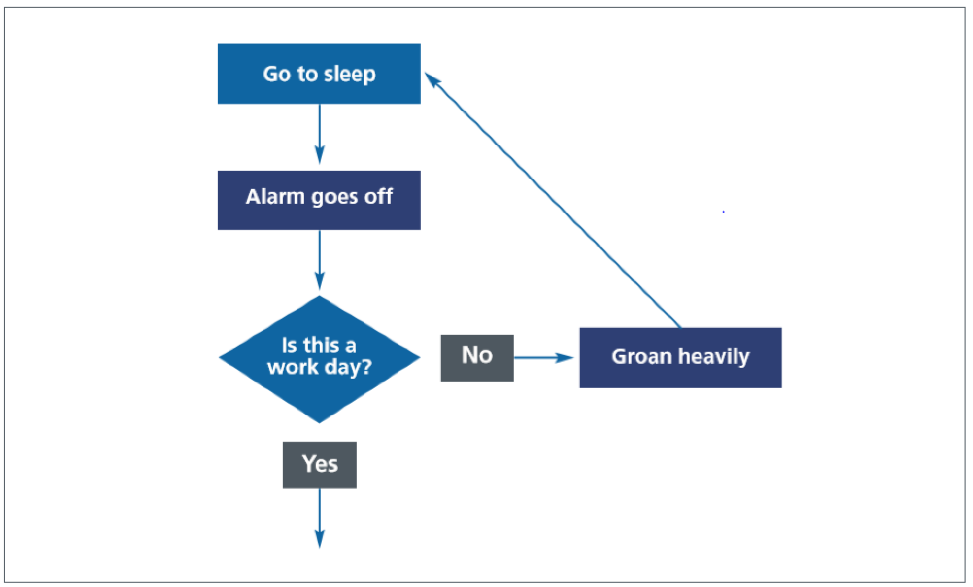

Process map key:

|  |  |  |
| --- | --- | --- |
| Shape | Description | Function |
|  | Box | Shows the activities of the process. |
|  | Diamond | Represents the stage in the process where a question is asked or a decision is required. |
|  | Oval | Shows the start of a process and the inputs required. Also used to mark the end of the process with the results or outputs. The symbol is the same for the start and end of a process to emphasis interdependency. |
|  | Arrows | Show the direction or flow of the process. |

Once you have your high-level process map you will start to be able to understand how the process works and where there are problems, as well as where the most value is added.

Further work maybe required to analyse the problem areas identified e.g. seek stakeholder feedback or further data collection. The information and level of detail required will depend on the scope of your project.

# Step 2: find the value

Look at the steps that you have identified and consider which of these actually add value to the patient. Can you trace the flow of value through the process? This may give you ideas for how the process could be streamlined.

# Step 3: make resource use visible

Using the resource/impact categories below, add them to your process map next to the relevant steps. (If you don’t have colours available, you can use letters, e.g. E1 = Environmental resource No. 1, S4 = Social impact No. 4, F2 = Financial resource No. 2) Can you now highlight the steps with the greatest resource use/impacts? You may decide to focus your improvement effort on one or more of these.

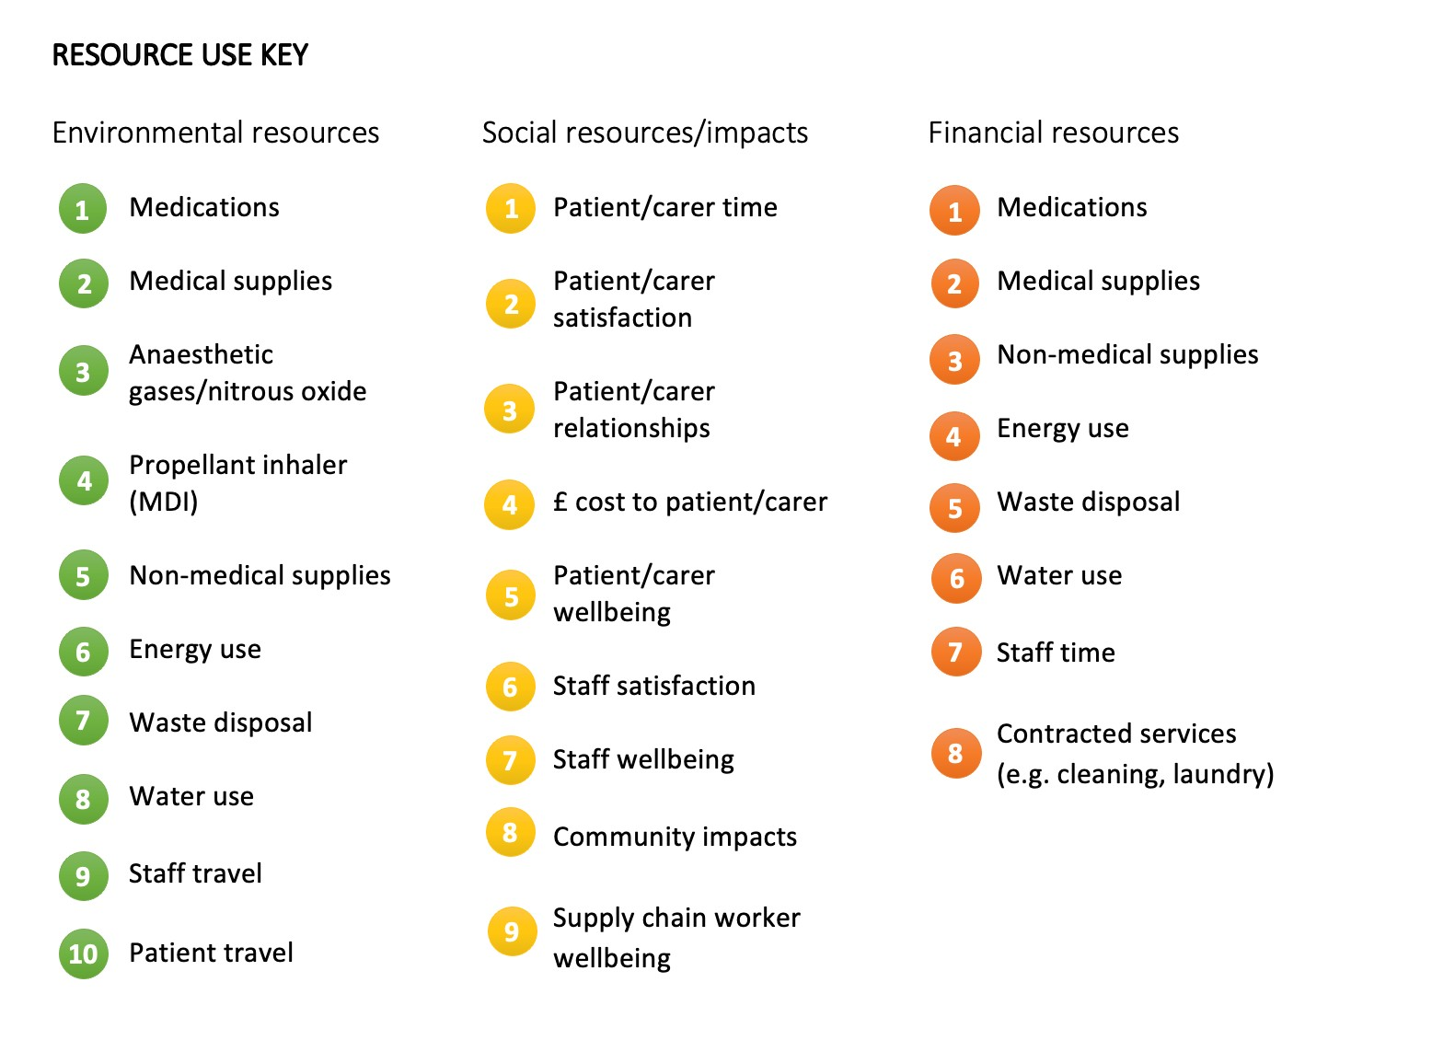

Acknowledgments

The graphic is taken from an NHS Improvement resource that is suitable for further reading on process mapping [qsir-conventional-process-mapping.pdf](https://aqua.nhs.uk/wp-content/uploads/2023/07/qsir-conventional-process-mapping.pdf)