Worksheet 1 COPD (Facilitator version 1.0) – Studying the system: environmental impacts
Background information for Facilitators
When thinking about the environmental impact of any healthcare intervention, there are several broad categories to consider.
Carbon footprint: this refers to the amount of greenhouse gases (GHG) emitted directly or indirectly attributable to a process, product or organisation usually expressed in kg CO₂ equivalents. Elements of healthcare activity with a measurable carbon footprint include:
- Energy use on site (burning fuel for heating, electricity use for lighting, cooking and cleaning etc)
- Release of anaesthetic gases / nitrous oxide
- Travel (staff, patients, carers)
- Pharmaceuticals and medical equipment (supply chain emissions – from manufacture and distribution)
- Non-medical equipment and supplies (supply chain emissions for furniture, IT equipment, laundry, etc.)
- Food production
- Waste disposal
Non-carbon impacts: A Carbon footprint is an important measure of environmental impact, but it is not the only one. Consider whether any of the following environmental impact categories apply to the Quality Improvement project, too:
- Air pollution: non-carbon pollutants from fossil fuel use or waste incineration (nitrogen oxides, particulate matter)
- Deforestation, landscape degradation, loss of biodiversity (mining and plantations for supply chains)
- Depletion of scarce natural resources, including fresh water
- Bio-accumulation and toxicity of chemicals entering the environment, often through water pollution (antibiotics, antidepressants, contraceptives, propofol)
- Plastic pollution from inadequate waste disposal systems / littering

Activity 1 – Study the system for environmental impacts
Task A: Read the scenario below and look at the process map. What environmental resources do you think are currently being used because of the frequent readmissions in this patient group? Can you identify the resource which is a carbon hotspot?
Consider the environmental impacts/resources used at each step of the process map and write your answers in table 1 column 2 below. Once you have completed your list of resources, identify which one you think is the carbon hotspot (i.e.. the resource with the most intense concentration of GreenHouse Gas (GHG) Carbon emissions). Please appoint a scribe in your group and someone to feedback your answers ready for when you return to the whole group.
Task B: What data could be collected to measure the resources you have identified? Think how you could measure the total amount of resources you have identified. Write your answer in table 1 column 3.
Facilitator note: Encourage students to think about each step of the process map and fill out table 1 (They may not get time to think of all the examples in the time allocated to the activity). The main aim is that they consider each area in the resource table so they begin to develop a skill of spotting carbon hotspots (in this case the pMDI) and a holistic sustainability lens when studying the system before designing the improvement. This exercise is also designed to encourage students to think about where they could find out and measure the data in order to measure the improvement later on in the Quality Improvement Project (QIP) process.
Scenario
Elizabeth is 83 years old. She is admitted to hospital via ambulance with rapid onset of worsening breathlessness. She is treated in ED for acute exacerbation of Chronic Obstructive Pulmonary Disease (COPD). She has a medical history of COPD and is a current smoker. In the Emergency Department, she is treated with nebulised salbutamol and ipratropium, oral antibiotics and oral steroids. Elizabeth is then admitted to the Care of the Elderly Ward.
She is discharged after 4 days after requiring only minimal therapy and is encouraged to continue her current regular medications. She is sent home by taxi. She has a follow-up appointment with her COPD nurse in her GP practice shortly after discharge to review her regular medication. Elizabeth is prescribed a new Metered-dose Inhaler (pMDI) Ventolin to help manage exacerbations. She lives alone in the centre of town near a busy road in a ground floor flat. She currently receives a social care package which includes one carer visit per day at her home for 30 min for a welfare check.
You notice that Elizabeth has been admitted to hospital with similar symptoms 6 times in the last year. You discuss the case with your team who tell you of many similar patients who are regularly re-admitted with mild acute exacerbations of COPD.
You decide to do an audit with your ward clerk to find out more about this problem. You discover that 200 COPD patients are admitted at least 4 times per year, with an average length of stay of 4 days. They are usually brought to the hospital by ambulance and go home by taxi after discharge. You also notice that 80% are prescribed a new Ventolin MDI inhaler on discharge, 15% are current smokers, and 30% live alone.

Facilitator Note: The purpose of this scenario is to encourage students to think about what might be the best solutions to this complex problem of frequently re-admitted elderly patients with exacerbations of chronic disease. The assumption is that they are receiving optimal medical therapy and therefore reviewing their medical management plan is not the sole solution. Learners might think about adding in oxygen therapy for example, which would not be suitable for patients who are smokers. Instead, this scenario gets learners to think about avoidable and preventable hospital admissions, or ways in which the pathway could be adapted to better suit these patients. The focus should be on how we help patients like Elizabeth to better manage their chronic illness to avoid a cycle of re-admissions with relatively little clinical benefit. This scenario could equally be adapted to other chronic illnesses which cause cycles of readmissions in your area of work.

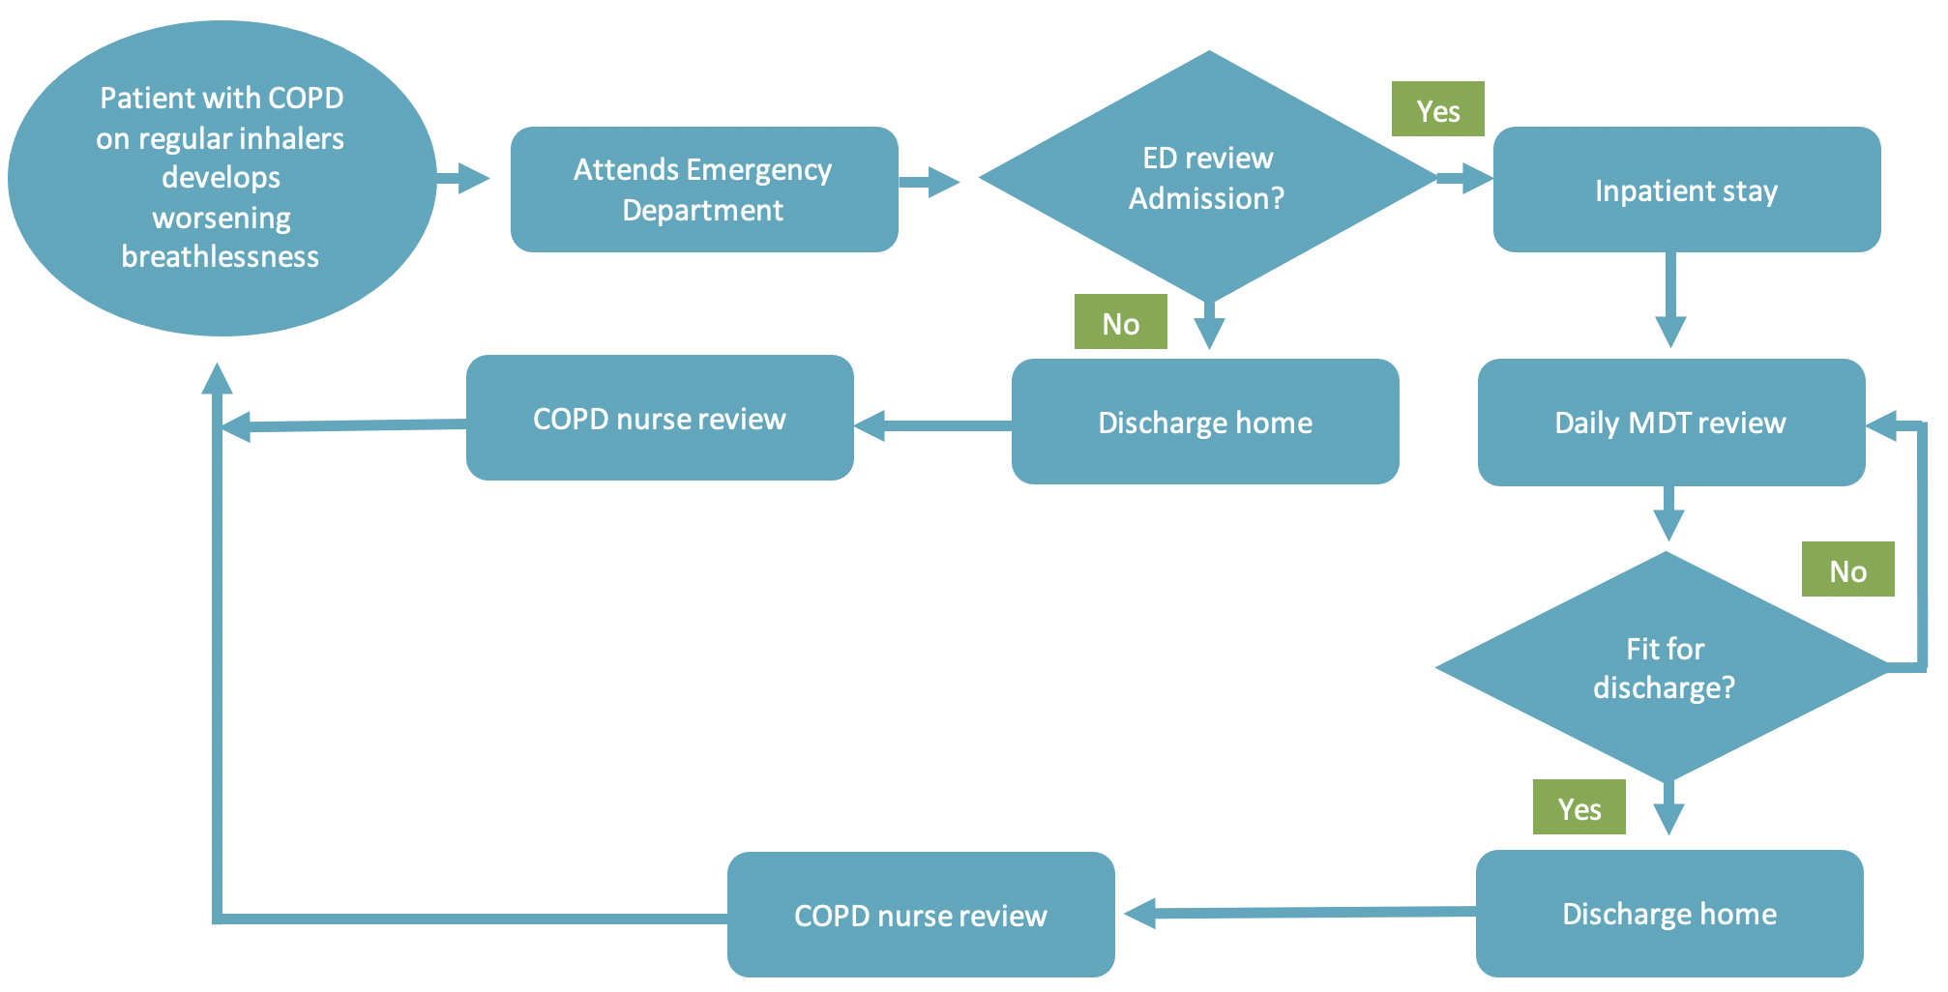

Table 1. Resource use
Activity/Resource | Task A: What resources are currently being used? | Task B: What data is available/ could be collected?
- Medical supplies
Medications | Salbutamol nebulisers, oral steroids, antibiotics, oxygen. (additional regular medication prescribed which hasn’t been brought in with the patient) | Pharmacy department
Anaesthetic gases / nitrous oxide | N/A
Propellant (MDI) inhalers | Metered Dose Inhaler- Ventolin (Carbon hotspot-GHG), | Pharmacy department
Medical & surgical equipment | Venturi valve/ O2 mask, O2 tubing, Nebuliser kit (Vaporizer Medicine Cup and mouthpiece). [NB: can encourage students to think whether equipment used by the ambulance crew & ED might be duplicated and/or not compatible which will increase resource usage e.g.ECG electrodes]  Staff PPE – Single-use masks, gloves, single-use plastic aprons, face shield/visors.  Covid19 tests, MRSA swabs.  Venepuncture and cannulation kit – (blood bottles, vacutainers and needles – cannula, bionector, sterile saline, gauze, antimicrobial skin prep wipes (e.g. Clinell wipes), surgical tape (e.g. micropore). | Procurement department, Pathology department.
Dressings | Cannular dressing (e.g.Tegaderm). | Procurement department
Diagnostic imaging & radiotherapy equipment & services | ?Chest x-ray | Medical notes/coding
Other, specify…
- Non-medical supplies
Office equipment, telecomms, computers & stationery | Paper medical notes/care plans, computers. | Health records department (sometimes known as medical records department)/IT department
Furniture fittings | Hospital beds, chairs, | Procurement department
Provisions | Food and drink | Catering department
Other, specify … | Bed linen, hospital gowns, toothbrushes, toothpaste, hairbrushes, single-use disposable razors, washing supplies (wipes, soap, shampoo), | Laundry services, procurement.
- Travel
Staff travel | Ambulance staff, hospital MDT staff.
Patient and carer travel | Ambulance journeys, family/friends (visitors) travel, taxi
- Energy use | Building energy – electricity, lighting, heating. | Estates department
- Water use | Drinking Water  Washing  Laundry | Estates department, Laundry Services department.
- Waste disposal | Clinical waste  Non-Clinical waste  Grey-water waste (bath, shower, sink and washing water)  Sewerage | Estates department
- Units of healthcare activity
Inpatient bed-day | 4 Inpatient bed-days per 10% of 1000 patients admitted last 6 months | Bed manager
Outpatient appointment | unknown
GP appointment | 4 GP follow-up appointments in 10% of 1000 patients | Secondary care data/ Primary care/CCG data.
Surgical or other procedure | unknown

