Worksheet 3 COPD – Designing the Improvement: prioritising improvement ideas
Background information
The driver diagram can be used to generate improvement ideas. Using the principles of sustainable healthcare, your ideas can be structured to address the two primary aims of sustainable healthcare-reducing healthcare activity and reducing the carbon intensity of healthcare. These aims will aim you to achieve the overall outcome of reducing carbon without reducing health.
There are often many potential improvement ideas that can be generated for our identified problem or ideal outcome. By understanding the impact of a potential improvement (in terms of environmental, social and health outcomes) as well its feasibility, you can start to prioritise the most impactful and achievable improvement.
Activity – Prioritising improvement ideas
Task: Score the impact and feasibility of improvement ideas for reducing readmission cycles amongst the eldery with chronic respiratory disease. Take each improvement idea in turn, and give it a score from 0-3 (0=no impact, 3=highest impact). You might also want to think of your own idea and add it to the list, using the principles of sustainable healthcare to inspire ideas.
Write your answers in the Prioritising improvement ideas table below. (Please appoint a scribe in your group and someone to feedback your answers when you return to the whole group).
Scenario
Elizabeth is 83 years old. She is admitted to hospital via ambulance with rapid onset of worsening breathlessness. She is treated in ED for acute exacerbation of Chronic Obstructive Pulmonary Disease (COPD). She has a medical history of COPD and is a current smoker. In the Emergency Department, she is treated with nebulised salbutamol and ipratropium, oral antibiotics and oral steroids. Elizabeth is then admitted to the Care of the Elderly Ward.
She is discharged after 4 days after requiring only minimal therapy and is encouraged to continue her current regular medications. She is sent home by taxi. She has a follow-up appointment with her COPD nurse in her GP practice shortly after discharge to review her regular medication. Elizabeth is prescribed a new Metered-dose Inhaler (pMDI) Ventolin to help manage exacerbations. She lives alone in the centre of town near a busy road in a ground floor flat. She currently receives a social care package which includes one carer visit per day at her home for 30 min for a welfare check.
You notice that Elizabeth has been admitted to hospital with similar symptoms 6 times in the last year. You discuss the case with your team who tell you of many similar patients who are regularly re-admitted with mild acute exacerbations of COPD.
You decide to do an audit with your ward clerk to find out more about this problem. You discover that 200 COPD patients are admitted at least 4 times per year, with an average length of stay of 4 days. They are usually brought to the hospital by ambulance and go home by taxi after discharge. You also notice that 80% are prescribed a new Ventolin MDI inhaler on discharge, 15% are current smokers, and 30% live alone.

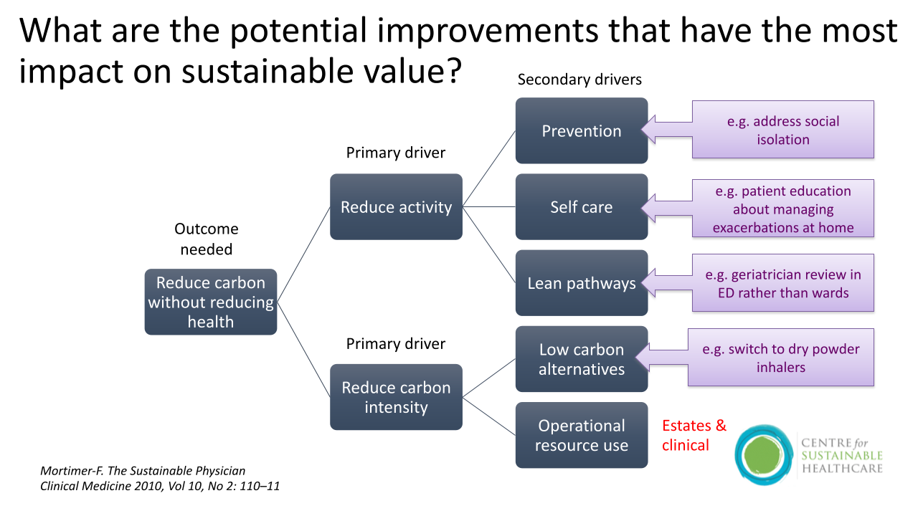

Prioritising improvement ideas table

Opportunity | Health Impact (0-3) | Environmental Impact (1-3) | Social impact (1-3) | Feasibility (1-3)
Address social isolation
Patient education about managing exacerbations at home
Geriatrician review on ED rather than wards
Switch to dry powder inhalers
Your group improvement idea

