Worksheet 1 COPD – Studying the system: environmental impacts
Activity 1 – Study the system for environmental impacts
Task A: Read the scenario below and look at the process map. What environmental resources do you think are currently being used because of the frequent readmissions in this patient group? Can you identify the resource which is a carbon hotspot?
Consider the environmental impacts/resources used at each step of the process map and write your answers in table 1 column 2 below. Once you have completed your list of resources, identify which one you think is the carbon hotspot (i.e.. the resource with the most intense concentration of GreenHouse Gas (GHG) Carbon emissions). Please appoint a scribe in your group and someone to feedback your answers ready for when you return to the whole group.
Task B: What data could be collected to measure the resources you have identified? Think how you could measure the total amount of resources you have identified. Write your answer in table 1 column 3.
Scenario
Elizabeth is 83 years old. She is admitted to hospital via ambulance with rapid onset of worsening breathlessness. She is treated in ED for acute exacerbation of Chronic Obstructive Pulmonary Disease (COPD). She has a medical history of COPD and is a current smoker. In the Emergency Department, she is treated with nebulised salbutamol and ipratropium, oral antibiotics and oral steroids. Elizabeth is then admitted to the Care of the Elderly Ward.
She is discharged after 4 days after requiring only minimal therapy and is encouraged to continue her current regular medications. She is sent home by taxi. She has a follow-up appointment with her COPD nurse in her GP practice shortly after discharge to review her regular medication. Elizabeth is prescribed a new Metered-dose Inhaler (pMDI) Ventolin to help manage exacerbations. She lives alone in the centre of town near a busy road in a ground floor flat. She currently receives a social care package which includes one carer visit per day at her home for 30 min for a welfare check.
You notice that Elizabeth has been admitted to hospital with similar symptoms 6 times in the last year. You discuss the case with your team who tell you of many similar patients who are regularly re-admitted with mild acute exacerbations of COPD.
You decide to do an audit with your ward clerk to find out more about this problem. You discover that 200 COPD patients are admitted at least 4 times per year, with an average length of stay of 4 days. They are usually brought to the hospital by ambulance and go home by taxi after discharge. You also notice that 80% are prescribed a new Ventolin MDI inhaler on discharge, 15% are current smokers, and 30% live alone.
[Look at the process map below]

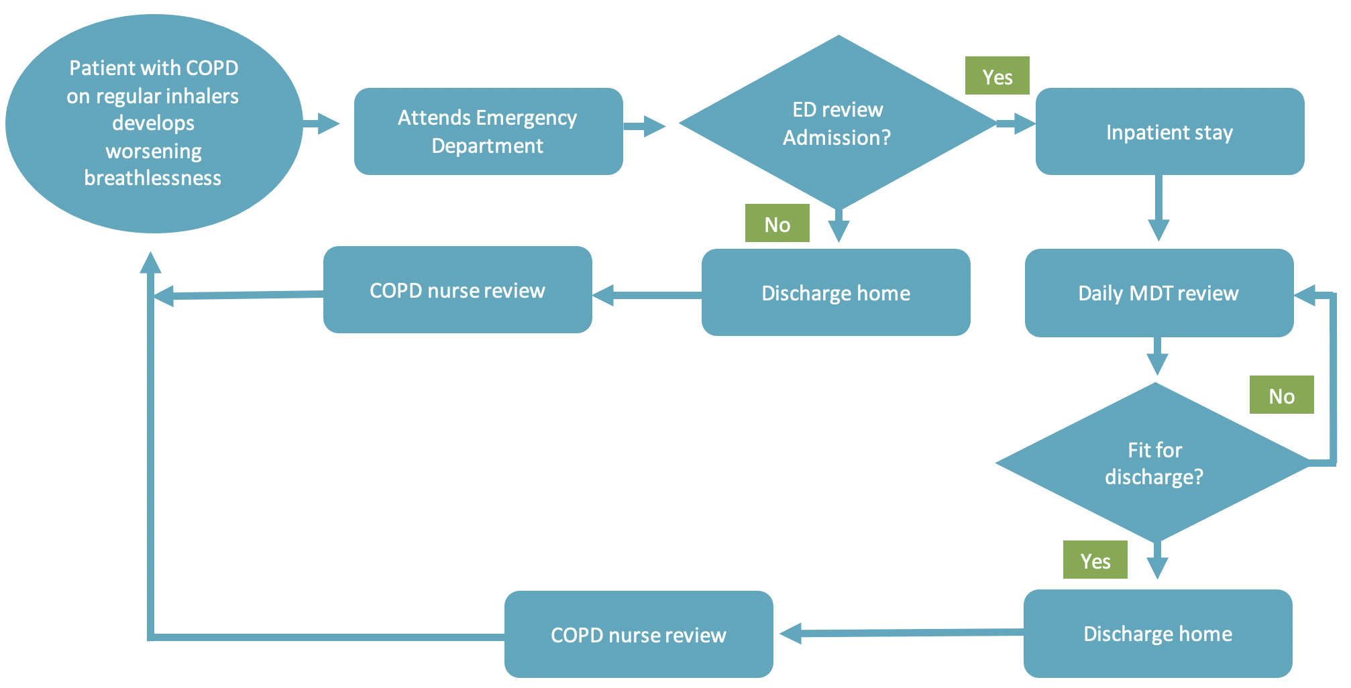
[Complete table 1. Resource use below]

Table 1. Resource use
Activity/Resource | Task A: What resources are currently being used? | Task B: What data is available/ could be collected?
- Medical supplies
Medications | e.g Salbutamol nebulisers, | e.g.Pharmacy department
Anaesthetic gases / nitrous oxide
Propellant (MDI) inhalers
Medical & surgical equipment
Dressings
Diagnostic imaging & radiotherapy equipment & services
Other, specify…
- Non-medical supplies
Office equipment, telecomms, computers & stationery
Furniture fittings
Provisions
Other, specify …
- Travel
Staff travel
Patient and carer travel
- Energy use
- Water use
- Waste disposal
- Units of healthcare activity
Inpatient bed-day
Outpatient appointment
GP appointment
Surgical or other procedure

[Complete Activity 2. on the next page]

