Worksheet 1 Asthma– Studying the system: environmental impacts
Activity – Study the system for environmental impacts
Task A: Read the scenario below and look at the process map. What environmental resources do you think are currently being used because of the frequent readmissions in this patient group? Can you identify the resource which represent a carbon hotspot?
Consider the environmental impacts/resources used at each step of the process map and write your answers in table 1 column 2 below. Once you have completed your list of resources, identify which one you think is the carbon hotspot (i.e., the resource with the most intense concentration of Greenhouse Gas (GHG) Carbon emissions). Please appoint a scribe in your group and someone to feedback your answers ready for when you return to the whole group.
Task B: What data could be collected to measure the resources you have identified? Think how you could measure the total amount of resources you have identified. Write your answer in table 1 column 3.

Scenario
Ali is 13 years old. He is admitted to hospital via ambulance with breathlessness and wheeze. He is treated in ED for a severe acute exacerbation of asthma. He has a medical history of asthma and has been admitted to hospital 3 times in the last year. He is treated with nebulised salbutamol and steroids in the Emergency Department and admitted to the Paediatric Inpatient Unit.
Ali is discharged after 4 days and is encouraged to continue taking his regular medications. On speaking with Ali, he tells the team that he often forgets to take his preventer inhaler, particularly during the week when he is busy with school. He is prescribed a new Ventolin inhaler and given his Asthma Plan for managing exacerbations.
Ali lives at home with his family in the centre of town near the ring road in a ground floor flat, and walks to school along a busy road.
You discuss the case with your team who tell you of many similar teenage patients who are regularly re-admitted with exacerbations of asthma in your area.
You decide to do an audit with your ward clerk to find out more about this problem. You discover that 200 asthma patients are admitted at least 4 times per year, with an average length of stay of 4 days. They are usually brought to the hospital by ambulance and go home by taxi or private vehicle after discharge. You also notice that 80% are prescribed a new Ventolin MDI inhaler on discharge, 25% report poor adherence to their asthma plans and 30% live within a mile of the local ring road.

[Look at the process map below]
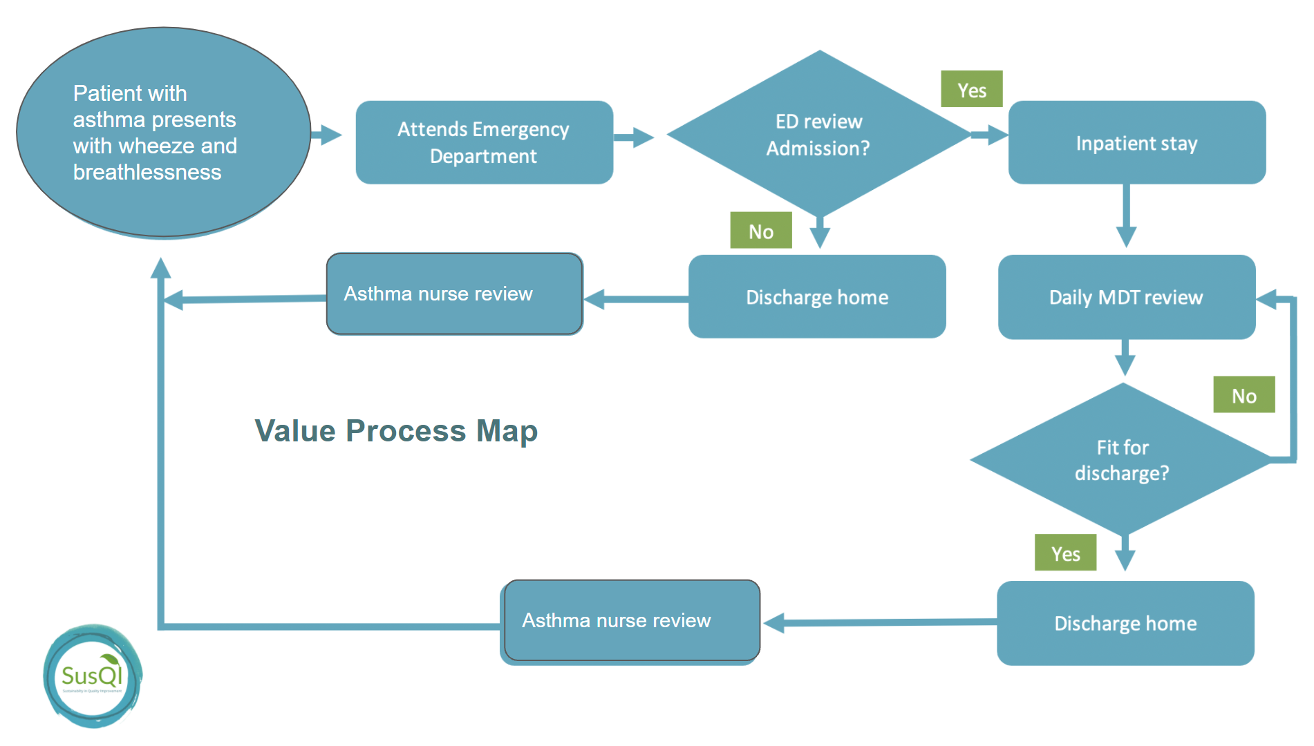
Patient with asthma presents with wheeze and breathlessness

[Complete table 1. Resource use below]

Table 1. Resource use
Activity/Resource | Task A: What resources are currently being used? | Task B: What data is available/ could be collected?
- Medical supplies
Medications | e.g Salbutamol nebulisers, | e.g.Pharmacy department
Anaesthetic gases / nitrous oxide
Propellant (MDI) inhalers
Medical & surgical equipment
Dressings
Diagnostic imaging & radiotherapy equipment & services
Other, specify…
- Non-medical supplies
Office equipment, telecomms, computers & stationery
Furniture fittings
Provisions
Other, specify …
- Travel
Staff travel
Patient and carer travel
- Energy use
- Water use
- Waste disposal
- Units of healthcare activity
Inpatient bed-day
Outpatient appointment
GP appointment
Surgical or other procedure

